Grand Stream SIP Phone Configuration.

* Login to DHCP IP of Sip Phone in browser
* Goto Account1 in Accounts🡪 Account1🡪General Settings

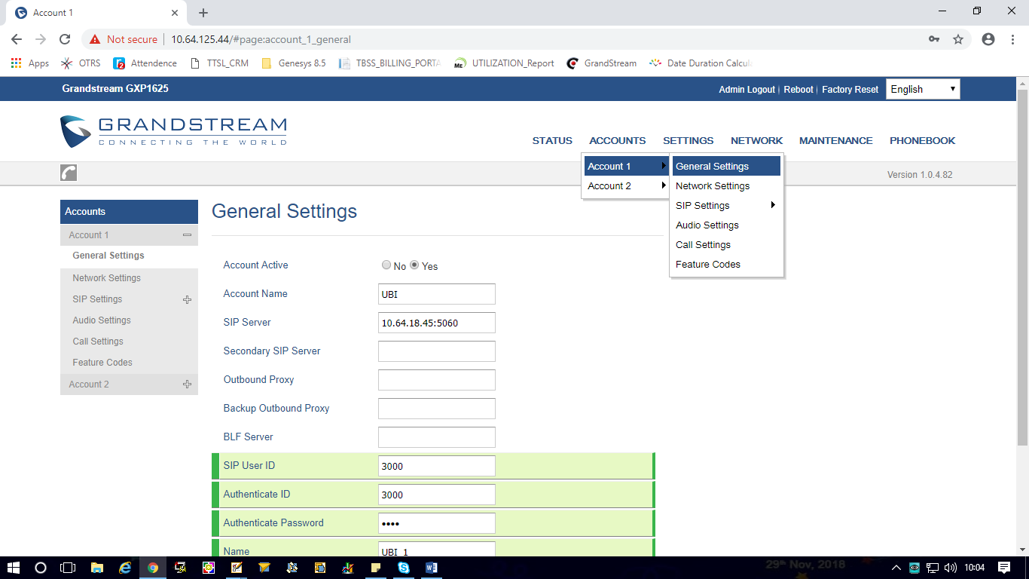

* Please Provide the general settings as mentioned in below snapshot.
* Change the SIP ID, Authentication ID and password.

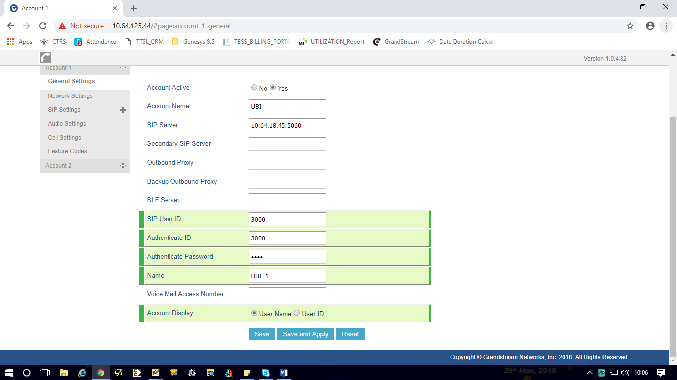

* Goto Network Settings and change according to below Snapshot

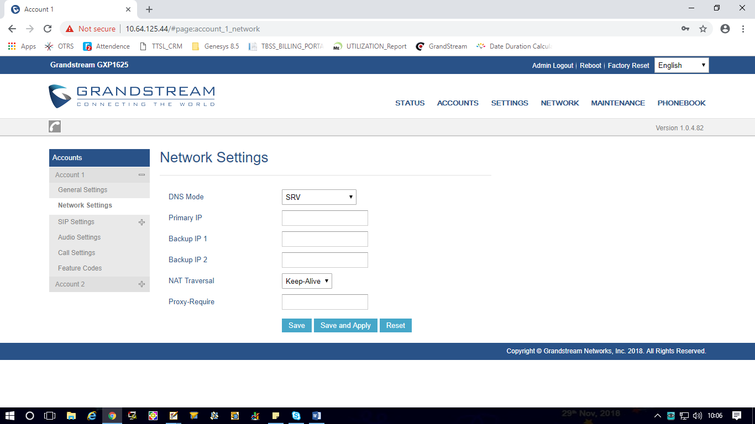

* Goto Sip basic settings

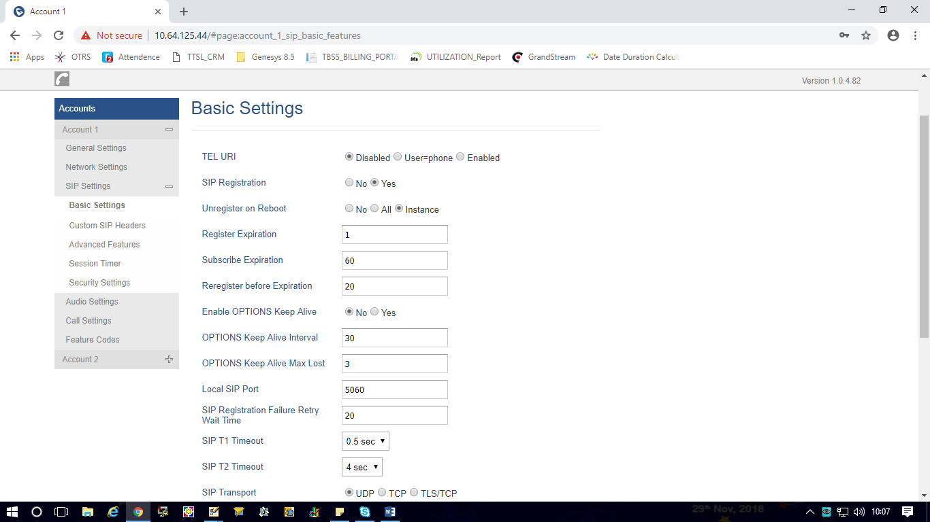

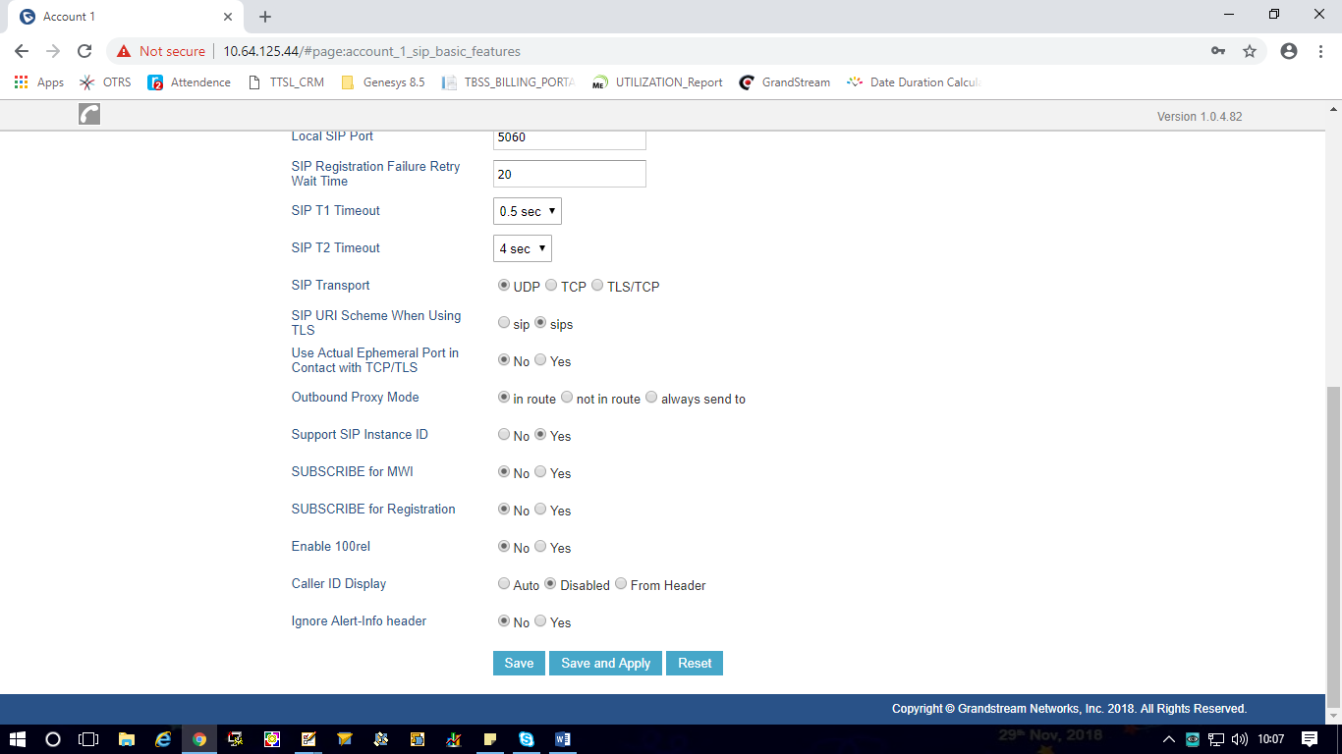

* **Audio Settings:**

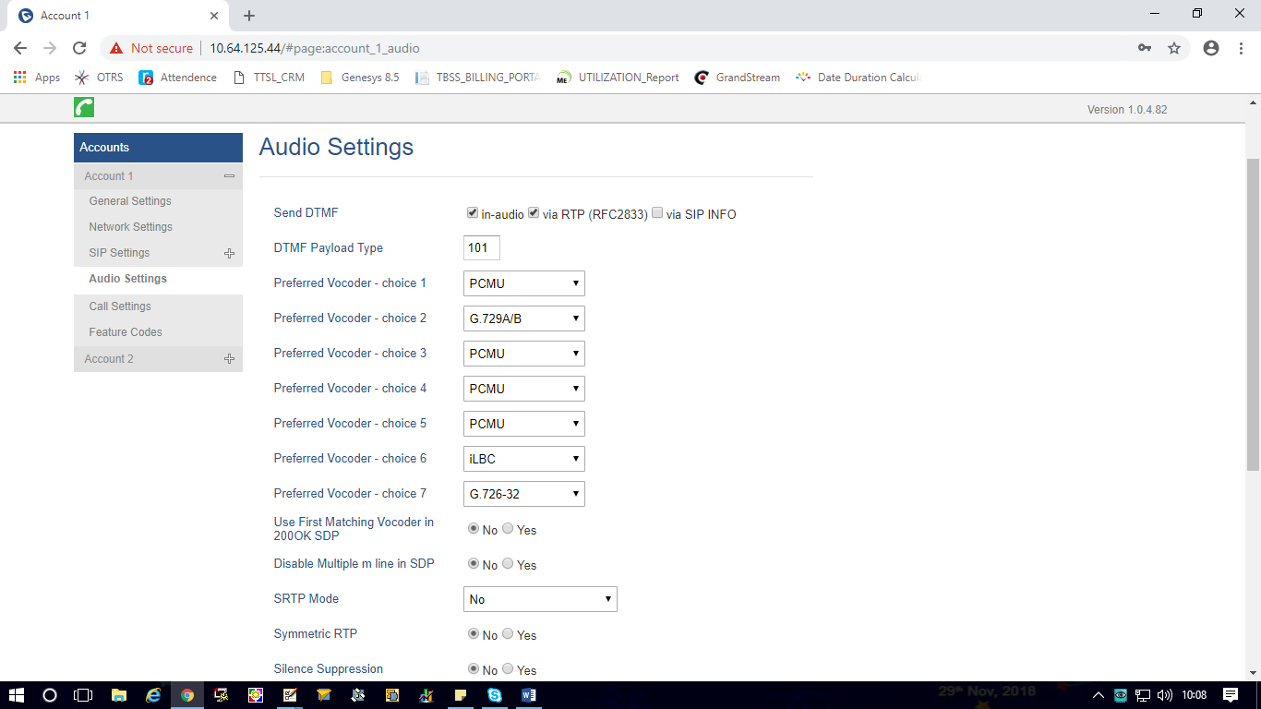

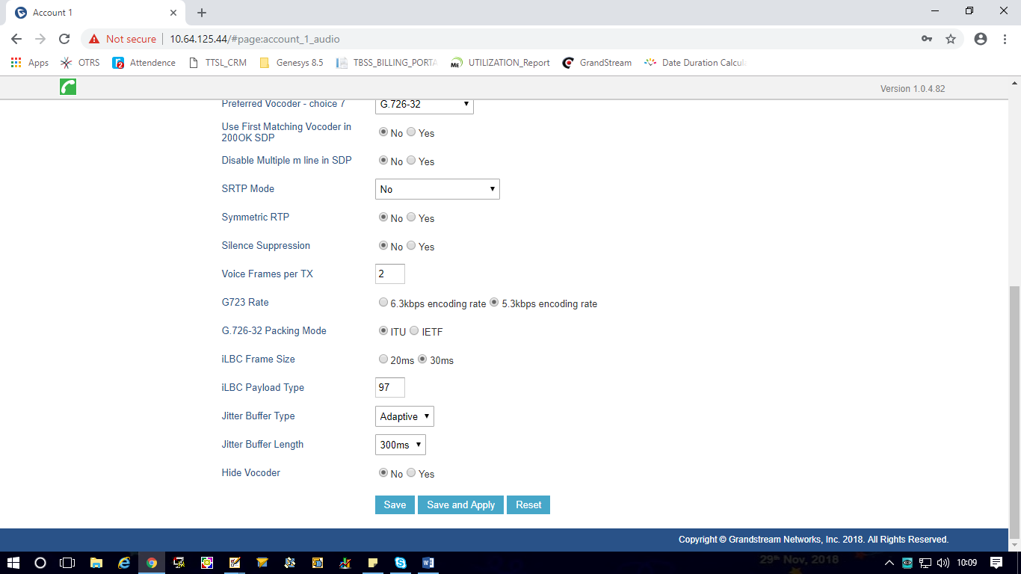

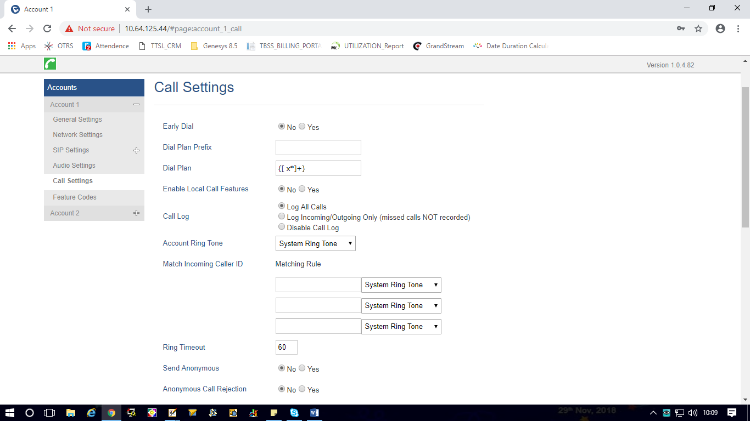

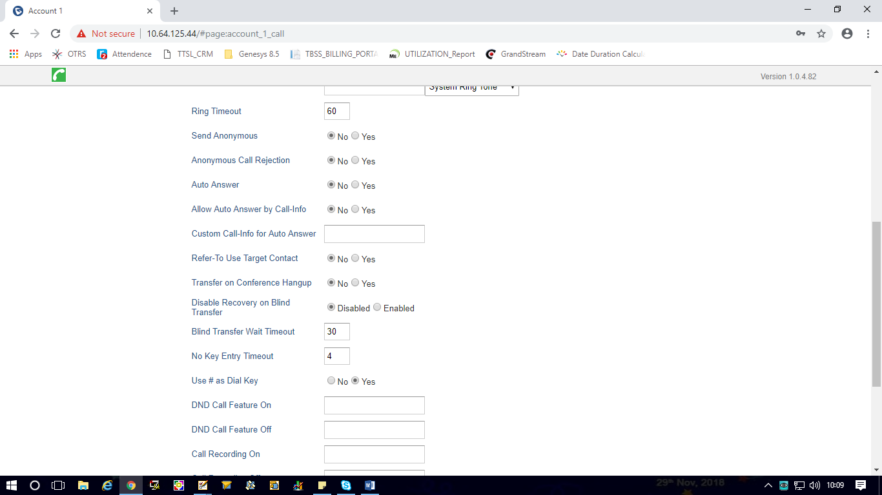

* Please find the URL for the configuration for clear understanding.

**https://www.callcentric.com/support/device/grandstream/gxp1625**